Chapter 2 p.28

AiTM domains growing as attacks become more common

Line graph showing growing AiTM domains. X-axis represents the period from June 2022 to June 2023 and y-axis represents AiTM domains from 0 to 10000 in intervals of 2000. Line starts from 2000 in Jun 22, goes down, increases gradually till 6500 in Oct 22, goes down to 3900 in Dec 22, and increases to 9000 in Mar 23. All the values are approximated.

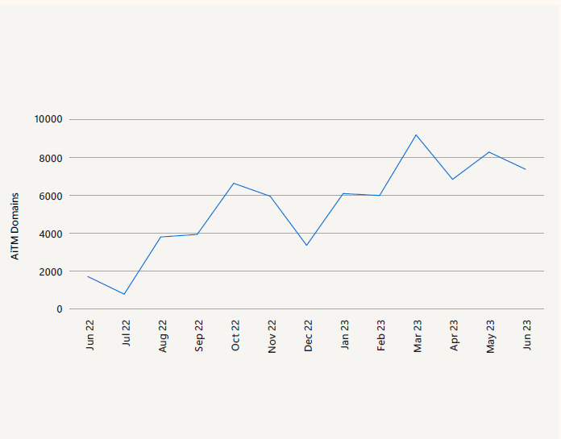Source: Microsoft Defender for Office 365